E-Pharmacy Managament System

CS162- Final Project Documentation



Project Supervisor

Mr. Samyan Qayyum Wahla

Project Members(Group Id 33)

|  |  |
| --- | --- |
| Member 1 Hafiz Mohsin Raza | Registration No.2020-C-81 |
| Member 2 Muhammad Ahmad | RegistrationNo.2020-CS-95 |

Department of Computer Science

University of Engineering and Technology, Lahore

Pakistan

Table of Contents

Project Description: 3

Project Features: 4

Technology Stack: 5

Use Cases: 5-10

User Interface Details 11

Classes: 12

Software Classes: 13-30

Domain Classes: 31-36

UML Diagram: 37

Object Oriented Features: 38-39

Composition: 38

Inheritance: 38

Multiple Inheritance: 39

Multi-Level Inheritance: 39

Polymorphism: 39

Testing: 40-54

Collections: 55

Exceptions: 55

Data Storage: 54-57

Project Plan 58

# Project Description:

E-Pharmacy management system has become a major part of our lives.It happens to get medicines without going to a medical store.It has become a neccessity of our lives to buy medicines but most of the people around us and including us don't have the time to go around to a medical store to buy medicines.There should be a online platform in every city of pakistan where we could buy medicines online without the hassle of going out in this time of rush and hustle and bustle.It is used to manage most e-pharmacy related activities in the pharmacy. It is used to manage most e-pharmacy related activities in the pharmacy.

Followinng are the benifits of E-Pharmacy management system:

* Avoiding too much writing tasks.
* Avoiding making too many files to maintain all the records.
* It would be easy to use.
* It would be easy to maintain.
* It would have regular updates of software to make it up to the date.
* Making our work easier.
* Keeping our data safe and sound.
* It would save a lot of money in the long run.
* It would be a one time buy software and save from spending money on files,papers,pens and a lot of things,etc.

This application would require the following requirements to run easily:

* Good laptop or pc
* Good system performance like good ram and rom.
* System windows like starting from Windows 7 and onwards,etc
* An agent or a person who knows how to use a computer or pc and and has the knowledge to run computer in a proper way.

Me and my partner would like to do project to ease the process of maintaining sales record of e-pharmacy.We would do this project in netbeans to create a desktop based application.

In this Project we will create a Java complete application of e-pharmacy management system. The application starts with a nice looking form which leads to a login form. The login form will be connected to a database, if the user id and password match the database entries, the user will login to the main form.

This program can be used in any pharmaceutical shops having a database to maintain. The software used can generate reports, as per the user’s requirements. The software can print invoices, etc. It can also maintain the record of supplies sent in by the supplier.

First of all we have to login to the main form.If password entered id correct,it will take us to the next page.But if we enter the password and it is wrong,it would display the message of wrong user id and password.

The Agent can go to the medicine form. He can add, edit, delete and view medicine stock.He can manage the overall activity of pharmacy and see all the details,etc.

The Agent can manage the different companies which provide medicine to the pharmacy by adding, editing and deleting them.

Finally, the Agent can sell medicine by using the Billing and by printing the Bill to the client.The Medical stores module basically deals with the information of medicine store products. This is done when the agent clicks on the ADD new button.

The client can select which medicine he wants to buy.He can add,delete,view update the medicine he wants to buy.He would have an oveerall user-friendly software and love this application and seeing the easiness to use the application he would to come to againa and again to buy medicines from this E-Pharmacy Management System

The navigation buttons provided helps the user to navigate through the records. The buttons are PREVIOUS and next. The option to edit, delete and save are also given so that the user can modify the records.The module also gives the information about the current stock level and the minimum stock level. If the stock level falls below the minimum value it will display a critical message, warning the user that the stock quantity level is low.

The Medicine Purchase deals with the purchase of the medicine from the suppliers. These medicines are then updated in the stock table.There are cases when the bill is sent later than the delivery of the products.

It would include the option to save data,update data,delete data,go to the previous page,exit,etc.

We click on SAVE to save the information and then click on print to print the receipt.We coyuld save the informqation by clicking on save button and it would store the data we want to save in the form of notepad format and if possible in the format of pdf format also for the easiness of both the client and agent who is using and operating the overall E-Pharmacy Management System application.

Overall, this would be a good management system which would increase our knowledge and help us to learn new things which would help us in the future and make our lives great.

**Work Breakdown Structure (WBS):**

* Requirement gathering
* Design the system flow
* GUI design
* GUI Implementation
* GUI backend programming
* Database design
* Database implementation
* Testing the system

**Goals and Objectives:**

Our goal is to provide a facility to pharmacist to overcome the problems faced at daily bases

1. Digitize the pharmacy records.

2. Maintain the invoices and medicine records.

3. Keep all sale and purchase records.

4. Maintain all employee records.

5. Serve customers as in short time as possible

**Project Features:**

In our E-Pharmacy Management System,these are the main features that will be used in this project .

* Users
* Drugs
* Drug Details
* Purchases
* Sales
* Company
* Setting
* Inbox
* Login
* Logout

Now this is the details of these features:

**1. Users**

* Add User information
* Search User information
* Edit User information
* Update User information
* Delete User information
* Show User List

**2. Drugs**

* Add Medicine / Drug data effectively
* Search Medicine /Drug data
* Edit medicine/ Drug information
* Update medicine/ Drug information
* Delete medicine/ Drug information
* Move Drug to other place
* Show Drug List

**3.Drug Details**

* Check Places where drug is place
* Edit Prices
* Expired Drugs Information
* Renew Validity of Drugs
* Almost Finished Drugs

**4.Purchases**

* Buy Drugs
* Update Drugs
* All Deals

**5.Sales**

* Sales Bills
* Shift Sales
* Retrieval Drug

**6.Company**

* Add Company Information
* Edit/Update Company Information
* Delete Company Information

**7.Setting**

* Login Details of Users
* Change Password
* Logout

**8.Inbox**

* Admin can send message to user about system
* User can send message to admin about system

**Technology Stack:**

|  |  |
| --- | --- |
| Language(C#/Java) | java |
| Platform(Web/Desktop) | Desktop |
| Frontend Technology(Simple HTML/Bootstrap/any other library) | Java Swing |
| IDEs | Java development Kit(JDK),Netbeans |
| Technology | MYSQL Workbench,MYSQL 8.0 Command Line Client ,  Java Swing. |

**Project Actors:**

The E-Pharmacy Management System has different actors

* Main Admin
* User
* Employee

**Use Cases:**

All the use cases should be written in the following format. The name of use should be start with a word e.g. Add Student. It should not be as Student/ Student Add. Add Student is separate use case and Edit Student is separate use case:

## Use Case 1(Write the name of the use case):

|  |  |
| --- | --- |
| Use Case ID | U01 |
| Name | MainScreen |
| Actor | Admin |
| Description | This is main screen . |
| Layout in pencil tool |  |
| Validators | When user login as admin that screen will open. |
| Use Case ID | U02 |
| Name | Login form |
| Actor | Admin |
| Description | This is login screen to login to system. |
| Layout in pencil tool |  |
| Validators | The username and password contains alphanumeric letters.User ID must be Integer and password is alphamuneric. |
| Use Case ID | U03 |
| Name | User form |
| Actor | Admin |
| Description | In this case we add User, update, delete user to system. |
| Layout in pencil tool |  |
| Use Case ID | U04 |
| Name | Drug form |
| Actor | Admin |
| Description | In this case we add , update, delete drug and also show drug List to system. |
| Layout in pencil tool |  |
| Use Case ID | U05 |
| Name | DrugDetails form |
| Actor | Admin |
| Description | In this case we add place of drug move drug to another place and also show expired drug and drug List to system. |
| Layout in pencil tool |  |
| Use Case ID | U06 |
| Name | Purchaseform |
| Actor | Admin |
| Description | In this case we show the purchase of drugs , new deal with company for drug and all deals to system. |
| Layout in pencil tool |  |

|  |  |
| --- | --- |
| Use Case ID | U07 |
| Name | Salesform |
| Actor | Admin |
| Description | In this case we show Sales bills,RenewValidity,and new sales the to system. |
| Layout in pencil tool |  |

|  |  |
| --- | --- |
| Use Case ID | U08 |
| Name | AddDrug form |
| Actor | Customer |
| Description | This screen add the information of drug like Drug ID,name,Type,description,,manufacturing and expiration date,quantity,price. |
| Layout in pencil tool |  |
| Validators | Drug ID should be numeric but drug name is alphanumeric. |
| Use Case ID | U010 |
| Name | Company information form |
| Actor | Admin |
| Description | This screen give the customer information like name,address,phone .etc |
| Layout in pencil tool |  |

# User Interface Details

In this section, fill the table for summary that which use case will have the required component. Inside each box, write the counts for each component. If component is not used, write zero.

|  |  |  |  |  |  |  |  |  |  |  |  |  |
| --- | --- | --- | --- | --- | --- | --- | --- | --- | --- | --- | --- | --- |
| Use Case Id | TextBox | DropDown | Password Box | Table | Date Field | Buttons | AutoComplete | Radio Button | CheckBox | Menu | Text Area | ProgressBar |
| U01 | 8 | 0 | 0 | 0 | 1 | 10 | 0 | 0 | 0 | 1 | 4 | 0 |
| U02 | 2 | 0 | 1 | 0 | 0 | 2 | 0 | 0 | 0 | 0 | 0 | 0 |
| U03 | 4 | 1 | 0 | 1 | 0 | 4 | 0 | 0 | 0 | 0 | 1 | 1 |
| U04 | 4 | 1 | 0 | 1 | 0 | 5 | 0 | 0 | 0 | 0 | 1 | 1 |
| U05 | 4 | 1 | 0 | 1 | 0 | 6 | 0 | 0 | 0 | 0 | 1 | 1 |
| U06 | 4 | 1 | 0 | 1 | 0 | 3 | 0 | 0 | 0 | 0 | 1 | 1 |
| U07 | 4 | 1 | 0 | 1 | 0 | 3 | 0 | 0 | 0 | 0 | 1 | 1 |
| U08 | 4 | 1 | 0 | 1 | 0 | 3 | 0 | 0 | 0 | 0 | 1 | 1 |
| U09 | 8 | 2 | 0 | 1 | 0 | 3 | 0 | 0 | 0 | 0 | 1 | 1 |
| U010 | 3 | 0 | 0 | 1 | 0 | 2 | 0 | 0 | 0 | 0 | 1 | 0 |

# Classes:

In this section, we do not require detailed design diagram. But identify the tentative classes with the requirement that you should have at least 10 domain classes and 5 software classes, 3 abstract classes, 2 singelton classes. Fill the following table for details. Note that class name should follow naming conventions

|  |  |  |  |  |
| --- | --- | --- | --- | --- |
| **Class Name** | **Software/ Domain** | **Is Abstract (Yes/No)** | **Is Singleton (Yes/No)** | **Is the class will has parametrized constructor(Yes/No)** |
| Login.java | Software | no | no | no |
| Change_pwd.java | Software | no | no | yes |
| ChangeStyle.java | Software | no | No | yes |
| Close_To_Finish.java | Software | no | no | yes |
| Company.java | Software | no | no | yes |
| Deal.java | Software | no | No | No |
| Drug_Buy.java | Software | no | no | yes |
| Pharmacy.java | software | no | no | yes |
| Drug.java | Software | no | No | yes |
| DrugList.java | Software | no | no | yes |
| EditPrice.java | Software | no | No | No |
| ExpiredDrugs.java | Software | no | no | yes |
| Inbox.java | Software | no | no | yes |
| LoginDetails.java | Software | no | No | No |
| MoveDrug.java | Software | no | no | yes |
| RnewValidity.java | Software | no | no | yes |
| RetrieveDrug.java | Software | no | No | No |
| SalesBill.java | Software | no | no | yes |
| SerachDrug.java | software | no | no | yes |
| Send.java | Software | no | No | yes |
| ShiftSales.java | Software | no | no | Yes |
| ShowMessage.java | Software | no | no | Yes |
| Use.java | Software | no | no | Yes |
| Warning.java | Software | no | no | Yes |
| WarningList.java | Software | no | no | Yes |
| CompanyDAOImp.java | Domain | no | no | Yes |
| DAO.java | Design pattern/Java Interface class | no | no | Yes |
| .DrugDAOImp.java | Domain | no | no | Yes |
| PurchaceDAOImp.java | Domain | no | no | Yes |
| UserDAOImp.java | Domain | no | no | Yes |
| CompanyPojo.java | Domain | no | no | Yes |
| DrugPojo.java | Domain | no | no | Yes |
| PurchasePojo.java | Domain | no | no | Yes |
| UserPojo.java | Domain | no | no | Yes |
| Connect.java | Singleton | no | no | Yes |

**Software Classes**

**JFrame forms:**

Following Forms used in this project:

|  |  |
| --- | --- |
| 1. Change_pwd |  |
| 2.Changestyle |  |
| 3.Close_To_Finish |  |
| 4.Company |  |
| 5.Deal |  |
| 6.Drug_Buy |  |
| 7.Drug |  |
| 8.DrugList |  |

|  |  |
| --- | --- |
| 9.EditPrice |  |
| 10.ExpiredDrug |  |
| 11.Inbox |  |
| 12.LoginDetails |  |
| 13.Login |  |
| 14.MoveDrug |  |
| 15.Pharmacy |  |
| 16.RenewValidity |  |

|  |  |
| --- | --- |
| 17.RetrieveDrug |  |
| 18.SalesBill |  |
| 19.SearchDrug |  |
| 20.Send |  |
| 21.ShiftSales |  |
| 22.ShowMessage |  |
| 23.User |  |
| 24.Warning |  |

|  |  |
| --- | --- |
| 25.WarningList |  |

**Domain Classes:**

Following are the Domain classes implemented in this Project:

|  |  |
| --- | --- |
| 1.CompanyDAOImp |  |
| 2.DAO |  |
| 3.DrugDAOImp |  |
| 4.PurchaceDAOImp |  |
| 5.UserDAOImp |  |
| 6.CompanyPojo |  |
| 7.DrugPojo |  |
| 8.PurchasePojo |  |

|  |  |
| --- | --- |
| 9.UserPojo |  |

|  |  |
| --- | --- |
| 10.Connect |  |

**UML:**

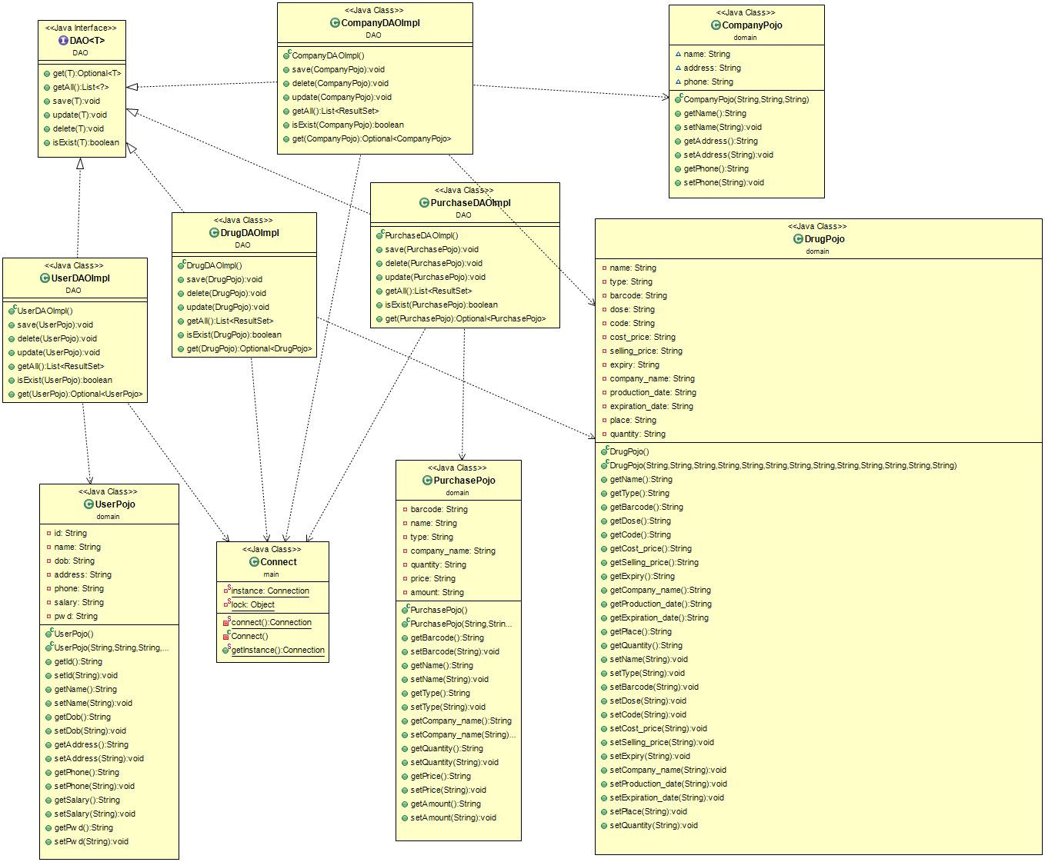

# Object Oriented Features:

## Composition:

In this section, Identify the at least three solid examples where composition can be perform. UML diagram 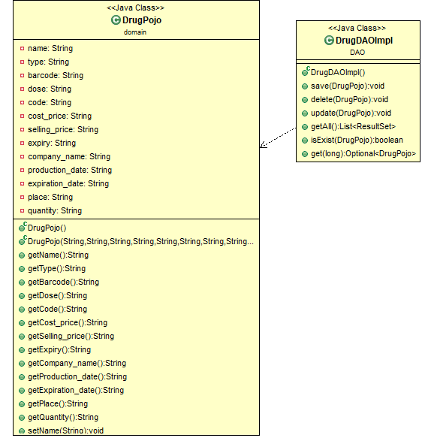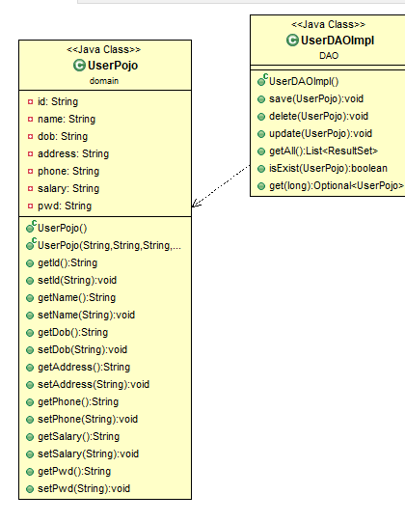

## Multiple Inheritance:

Two example with UML diagrams of multiple inherit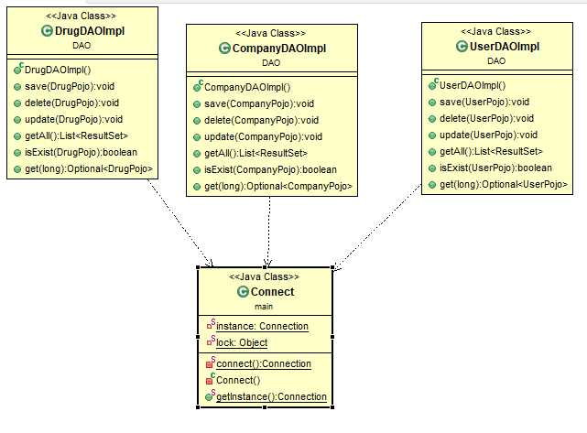

## Multi-Level Inheritance:

Two examples with UML diagrams of multi-level inheritance.

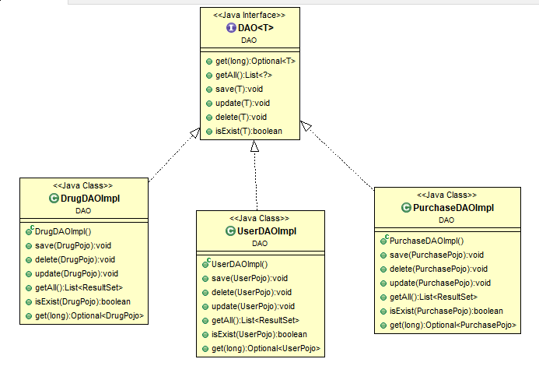

## Polymorphism:

At least 3 examples with UML diagram for polymorphism.



# Collections:

In this section, describe how and where you will use the following collections and why you are forced to use these collections.

ArrayList, LinkedList, Queue, Stack, HashSet and TreeSet

In this project we use Array List in different classes.Like Company.java because we print company List

use List in different classes.Like CompanyDAOImp.java because we print company List ..

We alse use array list to show drug list.

# Exceptions:

In this sections, identify at high level which type of exceptions you can face in your code and what are the solutions. Add more rows in the table as per requirements.

|  |  |  |
| --- | --- | --- |
| Type of Exception | Why this exception will occur | How you will handle the exception |
|  |  |  |
|  |  |  |

**Testing:**

1.Main Screen when login to System as admin

2. Main Screen when login to System as Employee which added by admin

|  |  |
| --- | --- |
|  | |
|  | |

|  |  |
| --- | --- |
| 1.Add User |  |
| Screenshoot |  |
| 2.Delete User |  |
| Screenshoot |  |
| 3.Update User |  |
| Screenshoot |  |
| 4.Add Drug |  |
| Screenshoot |  |

|  |  |
| --- | --- |
| Update Drug |  |
| Delete Drug |  |
|  |  |
| Drug List |  |
| Drug List sorted by name  Drug List sorted by Type |  |
| Search Drug by Name  And by Drug Barcode |  |
| Expird Drug |  |
| Renew Validity |  |

|  |  |  |
| --- | --- | --- |
| Move Drug |  | |
| Edit Prices |  | |
| Almost Finished drug |  | |
| Buy Drug |  | |
| Update Deal |  | |
| Deal List |  | |
| Sales Bills |  | |
| Shift Sales |  | |
| Retrieval drug |  | |
| Add Company | |  |
| Delete Company | |  |
| Update Company | |  |
| Login Details | |  |
| Change Password | |  |
| Purchase Drug Deleted | |  |
| Inbox | |  |

# Data Storage:

In this sections, describe the five files with their format from where you will read or store data. In case of database table, write down the names of columns for tables. At least 5 files/ tables are required.

We created this project with database MYSQL Workbench and following tables are used in my project:

**1. Drugs**

Following format of drug table:

+---------+-----------+-----------------+----------+------+------------+---------------+-------------------+--------------+----

| NAME | TYPE | BARCODE | DOSE | CODE | COST_PRICE | SELLING_PRICE | EXPIRY COMPANY_NAME | PRODUCTION_DATE | EXPIRATION_DATE | PLACE | QUANTITY |

+---------+-----------+-----------------+----------+------+------------+---------------+-------------------+--------------+----

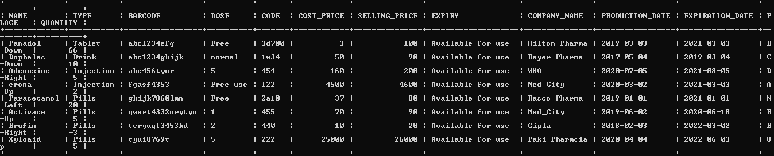

**2.Purchase**

Following format of Purchase table:

+-----------------+--------+-------+--------------+----------+-------+--------+--------------------+-----------

| BARCODE | NAME | TYPE | COMPANY_NAME | QUANTITY | PRICE | AMOUNT |

+-----------------+--------+-------+--------------+----------+-------+--------+--------------------+-----------

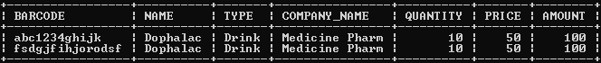

**3.User**

Following format of User table:

+----+----------+------------+-------------+-------------+--------+----------+------------------+

| ID | NAME | DOB | ADDRESS | PHONE | SALARY | PASSWORD |

+----+----------+------------+-------------+-------------+--------+----------+-------------------+

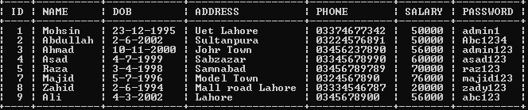

**4.Company**

Following format of Company table:

+---------------+-----------+-------------+

| NAME | ADDRESS | PHONE

+---------------+-----------+-------------+

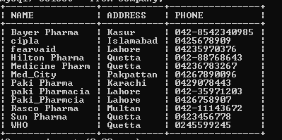

**5.History_Sales**

Following format of History_Sales table:

+-----------+---------------+---------+-------+------+----------+-------+--------+------------+-------------+------------------

| USER_NAME | BARCODE | NAME | TYPE | DOSE | QUANTITY | PRICE | AMOUNT | DATE | TIME |

+-----------+---------------+---------+-------+------+----------+-------+--------+------------+-------------+------------------

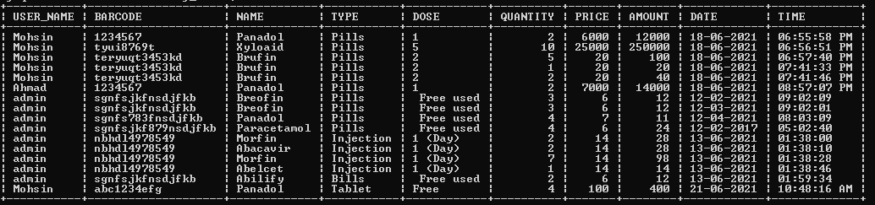

**6.Login**

Following format of Login table:

+--------+----------+------------+----------+

| NAME | TYPE | DATE | TIME

+--------+----------+------------+----------+

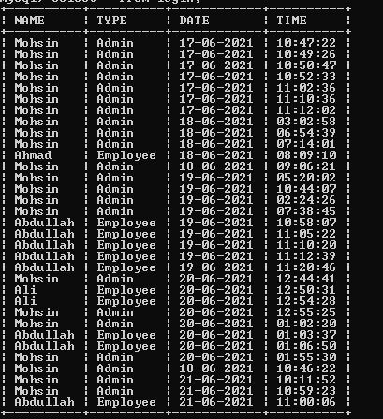

**7.Inbox**

Following format of Inbox table:

+--------------+------------+------------------------------+----------------------

| MESSAGE_FROM | MESSAGE_TO | MESSAGE_TEXT |

+--------------+------------+------------------------------+----------------------

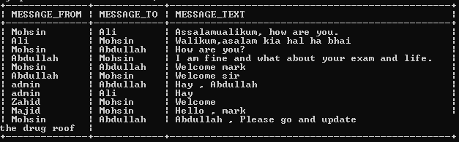

**Project Plan**

This section should include the implementation plan and work division among the members. All the estimated dates should be before June 15, 2021

|  |  |  |  |
| --- | --- | --- | --- |
| **Use Case Id** | **Use Case Name** | **Member Name** | **Estimated Completion Date** |
| U01 | Login | Hafiz Mohsin Raza | 21-05-2021 |
| U02 | MainMenu | Muhammad Ahamd | 21-05-2021 |
| U03 | AddUser | Hafiz Mohsin Raza | 21-05-2021 |
| U04 | DeleteUser | Muhammad Ahamd | 22-05-2021 |
| U05 | UpdateUser | Hafiz Mohsin Raza | 22-05-2021 |
| U06 | DeleteDrug | Muhammad Ahamd | 23-05-2021 |
| U07 | UpdateDrug | Hafiz Mohsin Raza | 25-05-2021 |
| U08 | Add Drug | Muhammad Ahamd | 29-05-2021 |
| U09 | AddCompany | Hafiz Mohsin Raza | 28-05-2021 |
| U010 | DeleteCompany | Muhammad Ahamd | 30-05-2021 |
| U011 | Drug List | Hafiz Mohsin Raza | 1-06-2021 |
| U012 | Serach Drug | Muhammad Ahamd | 3-06-2021 |
| U014 | Purchase Drug | Hafiz Mohsin Raza | 5-06-2021 |
| U015 | Sales Bills | Muhammad Ahamd | 12-06-2021 |
| U015 | Shift Sales | Hafiz Mohsin Raza | 14-06-2021 |
| U016 | Login Details | Muhammad Ahamd | 15-06-2021 |
| U017 | Change Password | Hafiz Mohsin Raza | 16-06-2021 |
| U018 | Inbox | Muhammad Ahamd | 17-06-2021 |
| U019 | RenewValidity | Hafiz Mohsin Raza | 18-06-2021 |
| U020 | Move Drug | Muhammad Ahamd | 19-06-2021 |
| U021 | Edit Prices | Hafiz Mohsin Raza | 20-06-2021 |
| U022 | Setting | Hafiz Mohsin Raza | 20-06-2021 |